Workplace experiences, emotional dissonance and subsequent intentions (FONT SIZE 16)

Arif Rahman^{1,a*}, Syarief Fajaruddin^{2,b}, M. Thoriq Aziz^{3,c}
¹Faculty of Islamic Studies, Universitas Ahmad Dahlan, Indonesia
²Universitas Negeri Yogyakarta, Indonesia
³Universitas Muhammadiyah Sukabumi

*arif.ayeb@gmail.com

ABSTRACT
(Abstract - text Calibri, size 11, italic. Spacing-SINGLE). The occurrences of workplace among practicum training students especially in the hospitality industry seem to be a never ending episode and each semester the same issue has been raised by the affected students. Practicum training students were identified to be the main target by bullies because of their temporary attachment nature with the organizations. Therefore, the objective of the study is to examine students’ subsequent career intentions in the hospitality industry after experiencing workplace bullying incidents and emotional dissonance during training. A sample of 232 diploma students majoring in culinary arts and hotel management from the universities was asked for input and results of the study showed several significant findings. The most important finding is the significant negative influences of workplace bully on the students’ subsequent career intentions. The findings therefore will help to address the issue more appropriately and plan for better training programs.
Keywords: Workplace, emotional dissonance, career intentions, hospitality students.
----------------------------------------------------------------------------------------------------------------------------------

Introduction
(The rest of the text Calibri, size 11. Spacing- SINGLE). Workplace especially on trainees has not been a common and special interests to managers in the hotel industry. The temporary attachment nature of student workers or trainees at the hotels has been seen to allow the incident to happen unnoticeably. It is a subject that has always been kept quiet by the employers or training managers to avoid scandal and adverse publicity that would later damage the image of the establishment. The nature of the industry has been portrayed through media as a rough and demanding workplace thus workplace bullying especially on trainees is a norm and is part of the job. Media coverage especially in the reality shows such as “Hell’s Kitchen”, which has glamorized the issue to the international audiences through his rough and advert comments are not really the actual reflection in real commercial kitchen situations (Bloisi & Hoel, 2008).

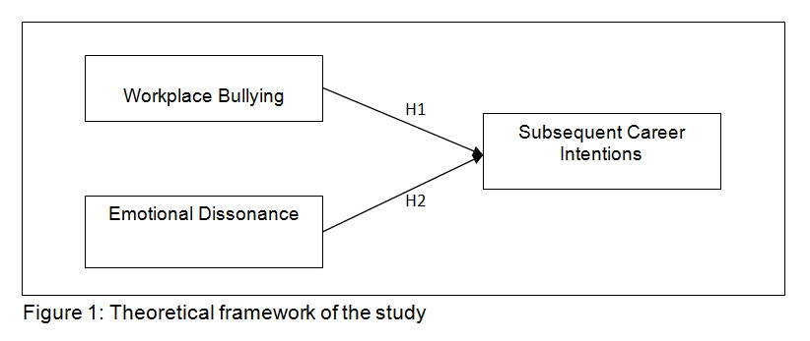
- Theoretical study
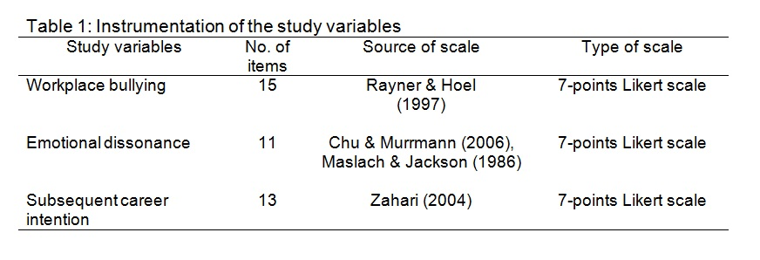
- the measures of the study variables used in the study

Method

Findings & Discussion

Conclussion

Acknowledgement
This paper is under scholarship of the university.

References
Abraham, R. (1999). Emotional dissonance in organizations: conceptualizing the roles of self-esteem and job-induced tension, Leadership & Organization Development Journal, 20(1), 18-25.

Bloisi, W., & Hoel, H. (2008). Abusive work practices and bullying among chefs: A review of the literature. International Journal of Hospitality Management, 27, 649-656.

Bubany, S. T., Krieshok, T. S., Black, M. D., & McKay, R. A. (2008). College students’ perspectives on their career decision making. Journal of Career Assessment, 16(2), 177-197.

Abraham, R. (1999). Emotional dissonance in organizations: conceptualizing the roles of self-esteem and job-induced tension, Leadership & Organization Development Journal, 20(1), 18-25.

Bloisi, W., & Hoel, H. (2008). Abusive work practices and bullying among chefs: A review of the literature. International Journal of Hospitality Management, 27, 649-656.

Bubany, S. T., Krieshok, T. S., Black, M. D., & McKay, R. A. (2008). College students’ perspectives on their career decision making. Journal of Career Assessment, 16(2), 177-197.

